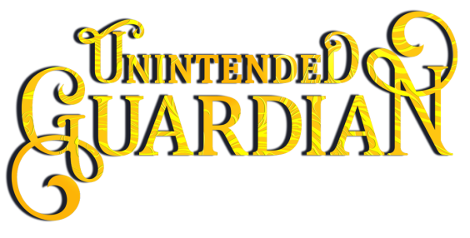

About Unintended Guardian, the free short story introduction to the Mythos Legacy:

Cursed to darkness,
a gryphon makes a wish for freedom.
She shows up instead…

A shapeshifting gryphon cursed to eternal darkness…

Sunlight shouldn’t be deadly to Griff Cyrus. Determined to break his curse, he follows an oracle’s bizarre instructions to have a magical package shipped to his apartment. Since when do brown trucks deliver mystical cures?

A lonely woman craving the spice of life…

Kala Kaneko’s social life couldn’t be more bland. When a strange parcel arrives at her door by mistake, she seizes the excuse to introduce herself to the intended recipient, her mysterious neighbor.

Fate has a twisted sense of humor…

Griff expects the package to free him from the curse, but opening the box unleashes a mythical creature bent on Kala’s death. Yet if Griff follows his instincts to protect her, he could sacrifice his last chance at freedom.

Amazon | iTunes | Google Play | B&N | Kobo | Additional Retailers

