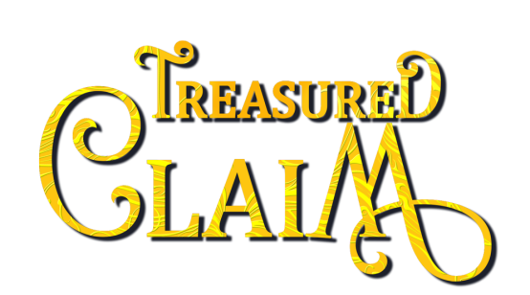

About Treasured Claim, the award-winning first novel of the Mythos Legacy series:

Desperate for treasure,
a dragon resorts to thievery,
but a knight steals her heart…

A shapeshifting dragon on the verge of starvation…

For Elaina Drake, sparkling jewels aren’t a frivolous matter. Without more treasure for her hoard, she’ll starve. On the run from her murderous father, she’s desperate enough to steal—er, acquire.

A modern-day knight seeking redemption…

Disgusted by his father’s immorality, Alexander Wyatt, Chicago’s biggest corporate titan, is determined to be a man of honor. Yet the theft of a necklace, stolen by an exotic beauty at his latest fundraiser, threatens to destroy all his charitable work.

A predator made prey…

Passion ignites between thief and philanthropist, sparking a game of temptation where jewelry is the prize. But when Elaina’s exposure jeopardizes Alex’s life, she must choose: run again to evade her father—or risk both their lives for love.

Amazon | iTunes | GooglePlay | B&N | Kobo | IndieBound | Additional Retailers

